Fleet Inspection And Maintenance
UX Mockups and Interaction Specification
Document owner | Version | Date | Status
Michael Yaacoub, Sr Solution Engineer | 1.0 | 2026-08-24 | Draft

This template follows the sample UX pack: each SCR screen pairs a visual mockup with a specification panel, and the pack closes with a navigation-flow map.

1. Experience Overview
The primary user is a driver standing beside a vehicle in a yard at six in the morning, in the dark or the rain, wanting to be on the road. A workshop controller and a fleet planner work the same records from a desk or a ramp-side tablet. Design principles: the checklist is one item at a time so nothing is skipped by scrolling; a grounding is stated in words that leave no room for interpretation; evidence is demanded where it matters and nowhere else; and no inspection is ever lost to a dead spot in the yard.
Persona | Primary goal | Device / viewport | Usage context
Driver | Complete the inspection quickly and know with certainty whether the vehicle is safe to drive | In-cab or personal handheld, 5 to 6 inch | Yard or roadside, outdoors, dark or wet, gloved, one-handed
Workshop controller | See defects immediately with evidence, and control release back to service | Tablet on the ramp and web at a desk | Workshop, moving between vehicles and the desk

2. Screen Inventory
Screen ID | Screen name | Mapped feature | User goal | Primary action
SCR-01 | Guided Vehicle Inspection | FEAT-01 | Complete the right checks for this vehicle | Submit the inspection
SCR-02 | Defect and Grounding | FEAT-02 | Know immediately whether the vehicle can be driven | Notify the workshop
SCR-03 | Workshop Repair and Release | FEAT-03 | Repair the defect and return the vehicle safely | Release to service
SCR-04 | Service Plan and Compliance | FEAT-04 | Service on usage and evidence it on demand | Export the record

3. Screen Mockups and Specifications

3.1 SCR-01 Guided Vehicle Inspection
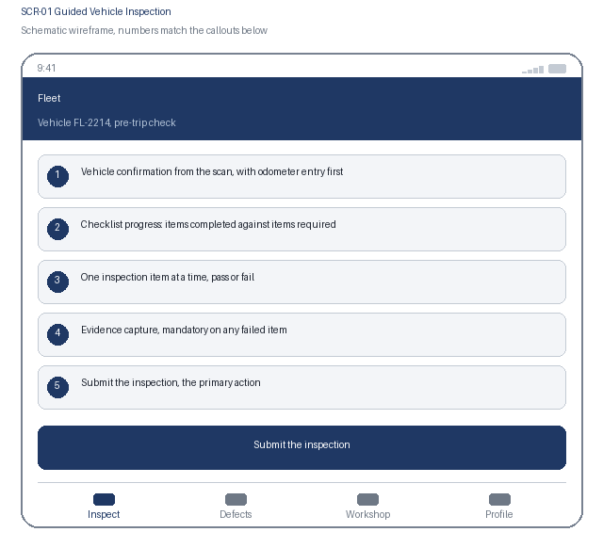  1. Vehicle confirmation from the scan, with odometer entry first  2. Checklist progress: items completed against items required  3. One inspection item at a time, pass or fail  4. Evidence capture, mandatory on any failed item  5. Submit the inspection, the primary action | Specification panel  Purpose: The driver completes the checklist that matches this vehicle type, one item at a time, with evidence demanded only where an item fails.  Primary action: Submit the inspection, which records the result and grounds the vehicle if any defect is critical.  Data: Vehicle identifier and type, regulatory category, odometer, checklist items with outcome, failure descriptions and photographs. Source: inspection service, checklist cached per vehicle type.  States: Vehicle confirmed, in progress, item failed, queued offline, submitted, grounded  Roles: Driver completes their own inspection; controller and planner read  Requirements: US-101, US-102, NFR-003, NFR-005, NFR-006

3.2 SCR-01 Interaction Details
Element / callout | Behavior | Validation | Accessibility
1. Vehicle scan | Confirms the vehicle and loads the matching checklist | A vehicle not assigned to this driver requires confirmation before continuing | Manual registration entry always available; confirmation announced
2. Odometer field | Requested before the checklist, pre-filled from telematics where available | Must be at or above the last recorded reading; a lower value requires an explanation | Numeric keyboard hint, pre-filled source stated, assertive error naming the expected minimum
3. Pass or fail control | A single item fills the screen; passing advances automatically to the next item | Every item must have an outcome; the count remaining is always visible | Two clearly labelled buttons rather than a toggle; the item text is the accessible name
4. Fail evidence | Failing an item opens photograph capture and a short description field | A photograph and at least 15 characters of description are mandatory before advancing | The requirement is stated before capture, not only after an attempt to continue

3.3 SCR-02 Defect and Grounding
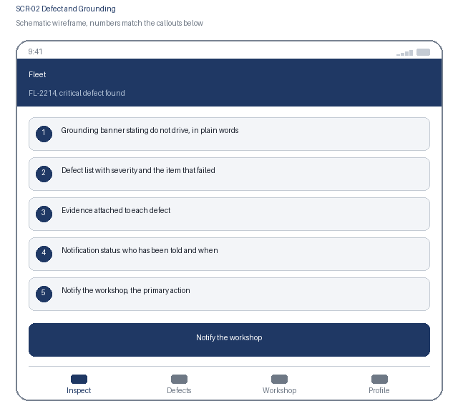  1. Grounding banner stating do not drive, in plain words  2. Defect list with severity and the item that failed  3. Evidence attached to each defect  4. Notification status: who has been told and when  5. Notify the workshop, the primary action | Specification panel  Purpose: The driver is told unambiguously that the vehicle is grounded, and the defect reaches the workshop with its evidence in minutes.  Primary action: Notify the workshop, which creates the workshop job and alerts the controller and duty manager.  Data: Grounding state and reason, defect list with severity and taxonomy code, evidence references, notification attempts with channel and outcome, vehicle location. Source: inspection service and notification dispatcher.  States: Grounded, grounding pending integration, notified, notification failed and retrying, workshop job created  Roles: Driver sees the grounding; controller and duty manager receive it; planner reads  Requirements: US-201, US-202, NFR-002, NFR-004, NFR-007

3.4 SCR-02 Interaction Details
Element / callout | Behavior | Validation | Accessibility
1. Grounding banner | Persists across the application until a recorded release | Cannot be dismissed by the driver; no client action clears it | Announced assertively on arrival and repeated on any attempt to start a trip
2. Defect row | Expands to show the failed item, description, photographs and taxonomy code | None | Disclosure with expanded state announced; severity stated as text, not colour alone
3. Notification status | Lists each recipient, channel and delivery outcome as it happens | A failure on every channel escalates to the duty manager and is shown here, never hidden | Updates announced through a polite live region as outcomes arrive
4. Start trip attempt | Blocked while the vehicle is grounded, from any screen | The block names the defect and states who can release the vehicle | The explanation is text, announced assertively, not a disabled control with no reason

3.5 SCR-03 Workshop Repair and Release
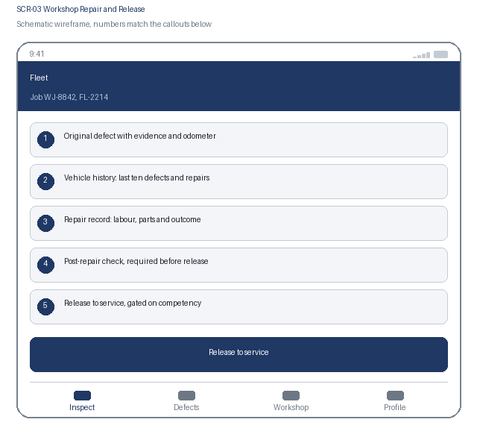  1. Original defect with evidence and odometer  2. Vehicle history: last ten defects and repairs  3. Repair record: labour, parts and outcome  4. Post-repair check, required before release  5. Release to service, gated on competency | Specification panel  Purpose: The technician works from the defect and its history, records the repair, and only a competent named person returns the vehicle to service.  Primary action: Release to service, which records the releaser and returns the vehicle to Available.  Data: Defect detail and evidence, vehicle defect history, labour hours, parts with quantity, repair outcome, post-repair check result, releaser identity and competency. Source: inspection service and training records.  States: Job open, in repair, awaiting post-repair check, release blocked by competency, released, vehicle available  Roles: Technician records the repair; only a competency holder releases; planner reads  Requirements: US-301, US-302, NFR-004, NFR-006

3.6 SCR-03 Interaction Details
Element / callout | Behavior | Validation | Accessibility
1. Repair record | Captures labour, parts and outcome against the job | Labour and outcome are mandatory; a parts line requires a quantity | Each field carries a visible label; totals announced through a polite live region
2. Post-repair check | A short verification checklist specific to the defect taxonomy code | Every item must pass before release becomes available; a failure returns the job to In repair | Checkbox group under a heading, with the blocked reason stated as text
3. Competency check | Evaluated server side when release is attempted | Release is blocked without the named competency, and the required competency is stated | The block explains what is missing rather than returning a generic permission error
4. Release to service | Clears the grounding and returns the vehicle to Available | Blocked while any defect on the vehicle remains open and unreleased, with each one listed | Confirmation states which defects are being released and by whom

3.7 SCR-04 Service Plan and Compliance
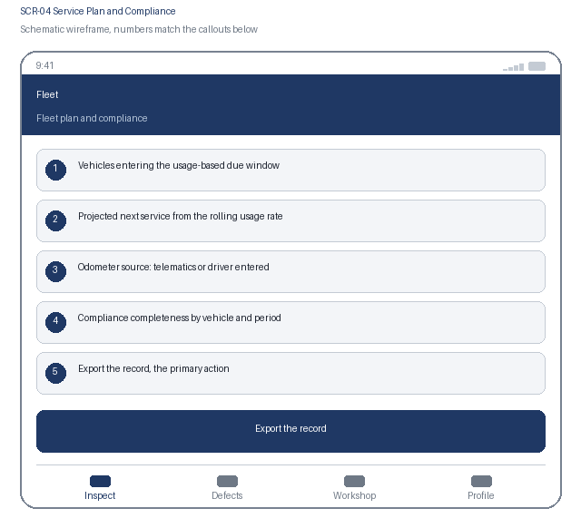  1. Vehicles entering the usage-based due window  2. Projected next service from the rolling usage rate  3. Odometer source: telematics or driver entered  4. Compliance completeness by vehicle and period  5. Export the record, the primary action | Specification panel  Purpose: The planner sees what is due from real usage rather than the calendar, and produces the evidence an inspector asks for without assembling it by hand.  Primary action: Export the record, which produces every inspection, defect, repair, release and service for the selected vehicles and period.  Data: Vehicle, rolling usage rate, projected service date and due window, last service, odometer source and age, inspection completeness percentage. Source: service plan calculator and inspection service.  States: Due soon, overdue, no recent odometer reading, export in progress, export complete  Roles: Planner and compliance manager; auditor reads the exported record  Requirements: US-401, US-402, NFR-001, NFR-006

3.8 SCR-04 Interaction Details
Element / callout | Behavior | Validation | Accessibility
1. Due window filter | Filters vehicles by how close they are to their projected service | An empty result names the active filter | Radio group with a visible legend and announced selection
2. Odometer source indicator | States whether the reading came from telematics or a driver, and how old it is | A vehicle with no reading for 7 days is flagged and excluded from projection | Source and age are stated as text; the flag is not conveyed by colour alone
3. Completeness figure | Shows the proportion of required inspections present for the period | Below the compliance threshold the figure is flagged and the missing dates are listed | The figure and the missing dates are both announced; the list is keyboard reachable
4. Export the record | Generates the export for the selected vehicles and period | A period longer than 12 months requires confirmation because of size; the export is never silently truncated | Progress and completion are announced; a download link is keyboard reachable

4. Navigation Flow
From | User action / condition | To | Alternate or error path
SCR-01 | Driver submits an inspection with a critical defect | SCR-02 | Clean inspection: the driver proceeds to trip start with no grounding
SCR-02 | Driver notifies the workshop | SCR-03 | Notification fails on every channel: the duty manager is paged and the grounding stands regardless
SCR-03 | A competency holder releases the vehicle | SCR-04, and the vehicle returns to Available | Release blocked by competency or an open defect: the job stays on SCR-03 with the reason stated
SCR-04 | Planner exports the compliance record | SCR-01 for the next inspection cycle | A vehicle has no recent odometer reading: it is flagged and excluded from projection
Flow: SCR-01 Guided Vehicle Inspection, submit, to SCR-02 Defect and Grounding, notify, to SCR-03 Workshop Repair and Release, release, to SCR-04 Service Plan and Compliance, and back to SCR-01 for the next inspection. A clean inspection goes straight from SCR-01 to the trip start, and the bottom tab bar reaches Inspect, Defects, Workshop and Profile.

5. Responsive Behavior
Viewport | Navigation | Layout | Content priority | Interaction changes
Phone | Bottom tab bar with four primary destinations | Single column, cards stacked in priority order | Grounding state first, then the current checklist item; nothing else competes | One-handed outdoor use with large targets; no swipe-only path to any action
Tablet | Adaptive left navigation rail | Vehicle list beside the selected vehicle's inspection and defect detail | Primary list beside the selected item's detail panel | Touch and pointer both supported; hover reveals nothing essential
Web | Persistent left navigation with breadcrumbs | Fleet register, defect queue and service plan in three columns | Dense scanning of many records, with full detail on selection | Full keyboard support with shortcuts for release and export; no hover-only affordance

6. States and Content
State | Trigger | Displayed content | Available actions
Loading | A data request is still in flight after 300 ms | Skeleton content preserving the final layout, with the checklist enabled as soon as the vehicle is confirmed | Cancel and retry remain available
Empty | A filter, search or assignment returns no records | A plain statement that no vehicles or defects match, naming the active filter | Clear the filter, or start a new inspection
Error | A request fails, times out, or is rejected by policy | What failed and, first, whether the vehicle is safe to drive | Retry; a grounding is never cleared by a failure
Offline | The device loses network connectivity | A persistent offline banner and a count of inspections waiting to submit | Inspection continues; a grounding is shown locally and confirmed server side after sync

7. Accessibility Requirements
- WCAG 2.2 AA is the conformance target for every screen, including all interactive states and error messaging.
- Every control is reachable in a logical tab order with a visible focus indicator, a programmatic label, and instructions announced before the input rather than only after an error.
- Errors are announced through an assertive live region, name the field, and describe how to correct the problem.
- Text contrast is at least 4.5 to 1 and non-text indicators at least 3 to 1; the interface remains usable at 200 percent text resize and at 320 CSS pixels wide.
- Motion is limited and honours the reduced-motion preference; no information is conveyed by colour alone.
- Touch targets are at least 44 by 44 CSS pixels with adequate spacing, so the interface stays usable with gloves or one hand.
- {Keyboard order, visible focus, labels, instructions, and error announcement behavior}
- {Contrast, text resize, reduced motion, screen-reader, and touch-target expectations}

8. Review and Approval
Reviewer | Role | Decision | Comments | Date
Design lead | UX design authority | Pending | Interaction model and visual specification
Accessibility specialist | Accessibility | Pending | WCAG 2.2 AA conformance evidence
Product owner | Business product owner | Pending | Screen inventory and flow confirmation

